Minutes 1.PP Meeting

Date: 17.1.2018
Time: 10:00 – 17:00
Place: Mistelbach (Barokschlössl)

Participants:
NÖ RU3: Peter Santner, Klemens Rybaczek
PP2 NIG: Gisela Reichholf, Martina Liehl-Rainer
PP3 NÖABB: Erwin Szlezak
PP4 KS NS MAS JMK: Vit Hrdousek
PP5 DSO: Antonin Okenka, Daria Ricarova
PP6 PZ: Martina Petrova
PP7 JMK: Tomas Grulich
PP8 KS NS MAS JCK: Tomas Novak, Marta Krejcickova, Milada Vopalkova, Adela Tomsovicova
PP9 JCK: Kamil Zimmermann, Ivana Randakova

Programme:
- 10:00 – 12:00 administrative Tasks
  - Short Introduction of all Participants
  - Infos concerning ERDF Contract
  - Projectreporting (Timetable + EMS)
  - Inputs Projectfolder
- 12:00 – 12:30 Lunch
- 12:30 – 16:00 Activities, Next Steps
  - Projecttimetable with Activities and Responsibilities
  - Changerequest (Is everything still like applicated?)
  - Preparing Start-Conference
  - Coordinating follow up Dates (Next PP-Meetings,…)
- 16:00 – 17:30 Excursion Soilprotection Plants (Windrow Headges)

Minutes:

Peter Santner greets all Partners and thanks for the Participation and congratulates for getting the Project approved. Special Thanks to our CZ-Partners for “fighting” for this Project.

The Meetinglanguage is set to English (with translation possibilities)

Each Person gives a short Introduction and their tasks in the Project.

Klemens Rybaczek takes the Moderation and leads through the Meeting.

- Info about ERDF Contract:
The ERDF Contract will be sent next week to the Leadpartner. Then also EMS Logins have to be created and Reporting is possible.
- Projectreporting:
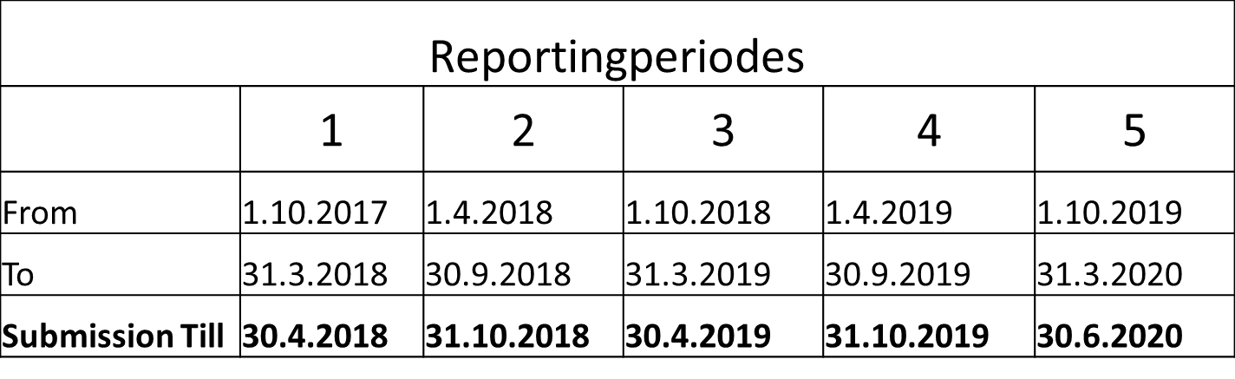 Submit Reports in Time!
Financial report only if more than 10.000€ for Periode and Partner
FLC check takes up to 90 days
We recommend Meeting with responsible FLC in order to check relevant points!
Always have eligiblity rules in mind!
- EMS-Reporting:
  - Available after ERDF-Contract Signature (LP)
  - „Projectreporting-Person“ (from each PP)
  - Activity Report = Linked with application!
    - Choose all Outputs where you have contributed during the reportingperiode and describe it.
    - Validate them with attachments (List of Participants, Fotos, Minutes, Scans, eg…) – Upload directly to the relevant Output
  - Financial Report = Linked with Budget!
    - Filling via Invoice-List (All relevant expenses have to be filled in)
    - Validate them directly with attachments (Invoices, Procurement documents,…)
    - Important: All Invoices have to contain “Project: Klimagrün” + Projectnumber: ATCZ142
  - Detailed Informations can be found in the EMS-Handbook – please read it

- Projectfolder
A first draft of the planned Projectfolder was shown from PP2 NIG Martina Liehl-Rainer.
the Input was, to produce maybe one folder wich contains both languages (CZ, DE).
- Lunchbreak
- Projectoverview
After the Lunchbreak the Activity, Responsibility and Budget Table was discussed. Therefore the Excel Controlling List was gone threw point for point.
Maintopics like Translation, Seminars, Equipment, Planting, … were discussed detailed.
Translation of Projectreports will be done from CZ-Partners and discussed during first Report.
For all other points it was agreed that each Partner has a look in detail at home and submits till 31.1.2017 all relevant informations.
Red marked points in the Excel Document should be changed!
- 1. Changerequest
As LP RU3 needs a Budgetshifting and many other Partners have changes as well, the first Changerequest will be done in mid of february.
Therefor all Partners agreed to send the relevant informations till 31.1.2017.
- Startconference
The Startconference was discussed and many points were fixed.
9.5.2018 / Tulln (UFT) / 10:00 – 17:30
Main Targetgroup (Other Projects, Initatives in the Field)
Programmedraft:
9:00 – 10:00 Arrival + (optional Excursion UFT)
10:00 – 10:45 Welcomming (also with politicians)
If possible also Ploitician from CZ
10:45 – 11:30 Projectpresentation (from 3 Regions)
11:30 – 11:45 Coffeebreak
11:45 – 12:45 Thematic Impulspresentation(s)
Do you have possible Speakers?
12:45 – 13:45 Lunchbreak
13:45 – 14:15 Guided Posterpresentations (other projects)
Each Partner can name 1 possible organisations
14:15 – 15:30 Networking, Discussions
15:30 – 17:30 Excursion (Garten Tulln) – with Bikes
We need official programme for inviting Politicians, Partners and interested people.
CZ-Expert could be Dr. Jan Pokormy (South bohemia – Trebon) cooperates with many universities. -> Tomas Novak will contact him (30 minutes presentation)
Input Vit Hrdousek: Plant a Climate Tree at Conference.
Max. 120 persons.
Simultanios Translation will be provided (CZ DE)

- Next Meeting
19. June 2018
Place: Budweis
Time and Programmedraft will be provided from LP.
Location and Catering will be organized from PP6-PZ

- Exkursion:
The Partners are invited to visit the regional Soilprotection palnts (Windrow Hedges)

Minutes: Klemens Rybaczek (with assistance of Martina Liehl-Rainer)

